**1. INTRODUCTION**

Now a day’s many of the industrial countries generate most of their electricity in large centralized facilities, such as fossil fuel (coal, gas powered) nuclear or hydropower plants because of their power demand. These plants have excellent economies of scale, which will usually transmit electricity for long distances. But these conventional energy generation systems can affect the environment. So to minimize these factors most of the developed countries goes to the on- site power generation by the solar photo voltaic systems to give the uninterrupted power supply to the load. This type of power generation called Distributed Generations (DGs).

Grid-Connected solar PV technologies are playing an increasingly important role in the nation’s energy scenario. They can be used to meet base load, peak power demand, backup power, remote power, power quality needs.

Grid interconnection of PV power generation system has the advantage of more effective utilization of generated power. However, the technical requirements from both the utility power system grid side and the PV system side need to be satisfied to ensure the safety of the PV installer and the reliability of the utility grid. Clarifying the technical requirements for grid interconnection and solving the problems such as islanding detection, harmonic distortion requirements and electromagnetic interference are therefore very important issues for widespread application of PV systems. Grid interconnection of PV systems is accomplished through the inverter, which convert dc power generated from PV modules to ac power used for ordinary power supply to electric equipments. Inverter system is therefore very important for grid connected PV systems.

Grid connection and extension costs are significant factors for integrating renewable energy sources-electricity (RES-E) generation technologies into an existing electricity network. Prices of both PV and BOS are decreasing following a trend of increased production and improved technology. This explains the high amount of subsidies for R&D and application of pvs in industrialized countries. The solar PV electric power generation will play an important role in the future energy supply in India.

In fact, growing of PV for electricity generation is one of the highest in the field of the renewable energies and this tendency is expected to continue in the next years. As an obvious consequence, an increasing number of new PV components and devices, mainly arrays and inverters, are coming on to the PV market. The energy production of a grid-connected PV system depends on various factors. Among these we distinguish the rated characteristics of the components of the PV system, the installation configuration, the geographical sitting of the PV system, its surrounding objects, and defects that occur during its operation. The need for PV arrays and inverters to be characterized has then become a more and more important aspect. Due to the variable nature of the operating conditions in PV systems, the complete characterization of these elements is quite a difficult issue.

**1.1 Solar Photovoltaic System**

Photovoltaic (PV) is a method of generating electrical power by converting solar radiation into direct current electricity using semiconductors that exhibit the photovoltaic effect. Photovoltaic power generation employs solar panels composed of a number of solar cells containing a photovoltaic material. Mainstream materials presently used for photovoltaic’s include mono crystalline silicon, polycrystalline silicon, amorphous silicon, cadmium telluride, and copper indium gallium solenoid/sulfide. Due to the increased demand for renewable energy sources, the manufacturing of solar cells and photovoltaic arrays has advanced considerably in recent years.

A photovoltaic system (informally, PV system) is an arrangement of components designed to supply usable electric power for a variety of purposes, using the Sun (or, less commonly, other light sources) as the power source

A photovoltaic array (also called a solar array) consists of multiple photovoltaic modules, casually referred to as solar panels, to convert solar radiation (sunlight) into usable direct current (DC) electricity. A photovoltaic system for residential, commercial, or industrial energy supply normally contains an array of photovoltaic (PV) modules, one or more DC to alternating current (AC) power converters (also known as inverters), a tracking system that supports the solar modules, electrical wiring and interconnections, and mounting for other components. Optionally, a photovoltaic system may include any or all of the following: renewable energy credit revenue-grade meter, maximum power point tracker (MPPT), battery system and charger, GPS solar tracker, energy management software, solar concentrators, solar irradiance sensors, anemometer, or task-specific accessories designed to meet specialized requirements for a system owner. The number of modules in the system determines the total DC watts capable of being generated by the solar array; however, the inverter ultimately governs the amount of AC watts that can be distributed for consumption. For example: A PV system comprising 11 kilowatts DC (Kw) worth of PV modules, paired with one 10-kilowatt AC (kW) inverter, will be limited by the maximum output of the inverter: 10 kW AC.

**1.2 Types of Solar PV Technologies**

Various materials display varying efficiencies and have varying costs. Materials for efficient solar cells must have characteristics matched to the spectrum of available light. Some cells are designed to efficiently convert wavelengths of solar light that reach the Earth surface. However, some solar cells are optimized for light absorption beyond Earth's atmosphere as well. Light absorbing materials can often be used in multiple physical configurations to take advantage of different light absorption and charge separation mechanisms.

Industrial photovoltaic solar cells are made of mono crystalline silicon, polycrystalline silicon, amorphous silicon, cadmium telluride or copper indium selenide/sulfide, Gas-based multi junction material systems.

Many currently available solar cells are made from bulk materials that are cut into wafers between 180 to 240 micrometers thick that are then processed like other semiconductors.

**1.2.1 Silicon Crystalline Technology**

The most prevalent *bulk* material for solar cells is crystalline silicon (abbreviated as a group as *c-Si*), also known as "solar grade silicon". Bulk silicon is separated into multiple categories according to crystalline and crystal size in the resulting ingot, ribbon, or wafer. These cells are entirely based around the concept of a p-n junction.

1. ***Monocrystalline Silicon* (c-Si):** Single-crystal wafer cells tend to be expensive, and because they are cut from cylindrical ingots, do not completely cover a square solar cell module without a substantial waste of refined silicon. Hence most *c-Si* panels have uncovered gaps at the four corners of the cells.
2. ***Polycrystalline Silicon*, Or *Multicrystalline Silicon*, (poly-Si or mc-Si):** made from cast square ingots — large blocks of molten silicon carefully cooled and solidified. Poly-Si cells are less expensive to produce than single crystal silicon cells, but are less efficient. United States Department of Energy data show that there were a higher number of polycrystalline sales than monocrystalline silicon sales.
3. ***Ribbon Silicon* is a type of polycrystalline silicon:** it is formed by drawing flat thin films from molten silicon and results in a polycrystalline structure. These cells have lower efficiencies than poly-Si, but save on production costs due to a great reduction in silicon waste, as this approach does not require sawing from ingots.
4. ***Mono-Like-Multi Silicon*:** Developed in the 2000s and introduced commercially around 2009, mono-like-multi, or cast-mono, uses existing polycrystalline casting chambers with small "seeds" of mono material. The result is a bulk mono-like material with poly around the outsides. When sawn apart for processing, the inner sections are high-efficiency mono-like cells (but square instead of "clipped"), while the outer edges are sold off as conventional poly. The result is line that produces mono-like cells at poly-like prices.

**1.2.2 Thin Film Technology**

Thin-film technologies reduce the amount of material required in creating the active material of solar cell. Most thin film solar cells are sandwiched between two panes of glass to make a module. Since silicon solar panels only use one pane of glass, thin film panels are approximately twice as heavy as crystalline silicon panels, although they have a smaller ecological impact (determined from life cycle analysis). The majority of film panels have significantly lower conversion efficiencies, lagging silicon by two to three percentage points. Thin-film solar technologies have enjoyed large investment due to the success of First Solar and the largely unfulfilled promise of lower cost and flexibility compared to wafer silicon cells, but they have not become mainstream solar products due to their lower efficiency and corresponding larger area consumption per watt production. Cadmium telluride (CdTe), copper indium gallium selenide (CIGS) and amorphous silicon (a-Si) are three thin-film technologies often used as outdoor photovoltaic solar power production. As of December 2013, CdTe was most cost effective (U.S. manufacturing cost per installed watt: $0.59 reported by First Solar) widely used thin film technology, and CIGS technology has the highest laboratory efficiency (20.4% as of December 2013), though CdTe cells made by First Solar have the highest industrial efficiency, and the lab efficiency of the immature GaAs thin film technology tops 28%.

1. **Cadmium telluride solar cell (CdTe)*:***A cadmium telluride solar cell uses a cadmium telluride (CdTe) thin film, a semiconductor layer to absorb and convert sunlight into electricity. One disadvantage of this technology, the only thin film material so far to rival crystalline silicon in cost/watt, is that cadmium is a deadly poison. Another issue is that tellurium (anion: "telluride") is a metal extremely rare in the earth's crust. The cadmium present in the cells would be toxic if released. However, release is impossible during normal operation of the cells and is unlikely during ﬁres in residential roofs. A square meter of CdTe contains approximately the same amount of Cd as a single C cell nickel-cadmium battery, in a more stable and less soluble form.
2. **Copper indium gallium selenide (CIGS)*:*** Copper indium gallium selenide (CIGS) is a direct band gap material. It has the highest efficiency (~20%) among thin film materials (see CIGS solar cell). Traditional methods of fabrication involve vacuum processes including co-evaporation and sputtering. Recent developments at IBM and Nanosolar attempt to lower the cost by using non-vacuum solution processes.
3. ***GaAs thin film cells****:* The Dutch Radboud University Nijmegen set the record for thin film solar cell efficiency using a single junction GaAs to 25.8% in August 2008 using only 4 µm thick GaAs layer which can be transferred from a wafer base to glass or plastic film. Recently, this record has been increased to 28.8%. The high efficiency obtained in GaAs thin film solar cells is attributed to the extreme high quality GaAs epitaxial growth, surface passivation by the AlGaAs,and the promotion of photon recycling by the thin film design

PV systems may be built in various configurations:

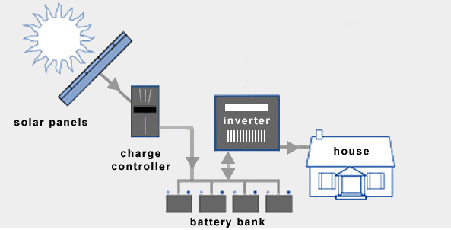 **Stand Alone System**

**Figure: 1.1 Standalone Solar PV System**

* Off-grid without battery (array-direct)
* Off-grid with battery storage for DC-only appliances
* Off-grid with battery storage for AC and DC appliances

A small PV system is capable of providing enough AC electricity to power a single home, or even an isolated device in the form of AC or DC electric. For example, military and civilian Earth observation satellites, street lights, construction and traffic signs, electric cars, solar-powered tents and electric aircraft may contain integrated photovoltaic systems to provide a

Primary or auxiliary power source in the form of AC or DC power, depending on the design and power demands.

**1.3 Grid Connected Solar PV System**

* Grid-tie without battery
* Grid-tie with battery storage

Large grid-connected photovoltaic power systems are capable of providing an energy supply for multiple consumers. The electricity generated can be stored, used directly (island/standalone plant), fed into a large electricity grid powered by central generation plants (grid-connected or grid-tied plant), or combined with one, or many, domestic electricity generators to feed into a small electrical grid (hybrid plant).PV systems are generally designed in order to ensure the highest energy yield for a given investment.

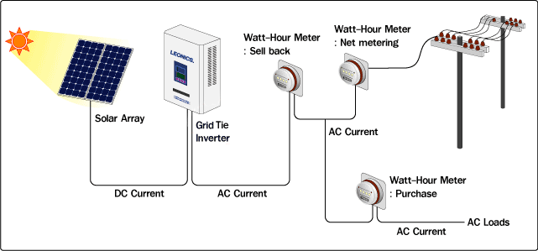

**Figure: 1.2 Grid Connected Solar PV System**

**1.4 Distributed Generation (Dg)**

The centralized and regulated electric utilities have always been the major source of electric power production and supply. However, the increase in demand for electric power has led to the development of distributed generation (DG) which can complement the central power by providing additional capacity to the users. These are small generating units which can be located at the consumer end or anywhere within the distribution system.

DG can be beneficial to the consumers as well as the utility. Consumers are interested in DG due to the various benefits associated with it: cost saving during peak demand charges, higher power quality and increased energy efficiency. The utilities can also benefit as it generally eliminates the cost needed for laying new transmission/distribution lines.

Distributed generation employs alternate resources such as micro-turbines, solar photovoltaic systems, fuel cells and wind energy systems. This project lays emphasis on the solar PV technology and its integration with the utility grid.

**1.5 Technical Impacts of Solar PV on The Distribution System**

**1.5.1 Network Voltage Changes and System Regulation**

Every distribution utility has an obligation to supply its customer’s electricity at a voltage within a specified limit. This requirement often determines the design and expense of the distribution circuit so that over the years techniques have been developed to make the maximum use of distribution circuits to supply customers within the required voltage. Some distribution utilities use more sophisticated control of the on load tap changers of the distribution transformer by using regulators on the feeder and also including the use of the current signal compounded with the voltage measurement at the switched capacitor on feeders. Feeding power from a Distribution Generator (DG) unit can cause negative impacts on the network voltage in case a DG unit is placed just downstream to a load tap-changer transformer. In this case, the regulators will not correctly measure the feeder demands. Rather, they will see lower values since the DG unit reduces the observed load due to the onsite power generation. This will lead to setting the voltage at lower values than that required to maintain adequate levels at the tail ends of the feeder. However, the most favorable locations of DG units near the end user terminals can provide the required voltage support at the feeder nodes.

**1.5.2 Power Quality**

Two aspects of power quality are usually considered to be important. One is transient voltage variations and other is the harmonic distortion of the network voltage. The Solar PV system can cause transient voltage variations on the network if relatively large current changes during connection and disconnection of the generator are allowed. Therefore, it is necessary to limit voltage variations to restrict the light variation. Generally, load fluctuation can cause voltage variation as well as source fluctuation. Solar PV units have the potential to cause unwanted transient voltage variations at the local power grid. The standalone operation of Solar PV units gives more potential for voltage variations due to load disturbances, which cause sudden current changes to the DG inverter. If the output impedance of the inverter is high enough, the changes in the current will cause significant changes in the voltage drop, and thus, the AC output voltage will fluctuate. Conversely, weak ties in the grid integration mode give a chance for transient voltage variations to take place but lower degrees than in the standalone mode.

Incorrectly designed or specified solar PV plants, with power electronic interfaces to the network, may inject harmonic currents, which can lead to an unacceptable network voltage distortion. The type and severity of these harmonics depend on the power converter technology, the interface configuration, and mode of operation]. Fortunately, most new inverters are based on Insulated Gate Bipolar Transistor (IGBT), which uses Pulse Width Modulation (PWM) to generate quasi-sine wave. Recent advances in semiconductor technology enable the use of higher frequencies for carrier wave, Hysteresis control which result in quite pure waveforms.

**1.5.3 Protection**

A number of different aspects of Grid connected Solar PV protection can be identified

* Protection of the generation equipment from internal faults.
* Protection of the faulted distribution network from fault currents supplied by the Solar PV system.
* Anti-islanding or loss-of-mains protection.
* Impact of Solar PV system on existing distribution system protection.

**1.6 Objectives of the Project**

This paper describes a control method for single-phase transformer less grid-connected inverter system for photovoltaic (PV) application. The system consists of a DC-DC Boost Converter and a full-bridge inverter. The DC-DC Boost Converter implements a Sensor less Maximum Power Point Tracker (MPPT).

**2. LITERATURE SURVEY**

**Bor-Jehng Kang and Chang-Ming Liaw,** Presented a paper on "A RobustHysteresis Current-Controlled PWM Inverter for Linear PMSM Driven Magnetic Suspended Positioning System"

Which states that This paper presents a single-band hysteresis current control for single-phase grid connected inverter. The effectiveness of the control scheme has been verified both by

simulation and experimentally. The current produced by this inverter is in phase with grid voltage and also achieve unity power factor. This method is robust and effective than

conventional reference signal generation by the controller and matching it with the grid voltage at later stage. This method also reduces the number of components such as Phase Lock Loop (PLL) circuits and cost significantly..

**The German Solar Energy Society**, paper deals with the “Planning and Installing Photovoltaic Systems. A guide for installers, architects and engineers” states that This paper presents a novel single band hysteresis current control with regulated MPP voltage for PV inverter system. The control strategy for the full bridge inverter retains all the benefits associated with hysteresis current control while the MPPT extracts maximum power from the solar arrays. The cost of this system will also be relatively low as minimum number of sensors and power devices used. It also proves that the proposed PV inverter system has low THD and suitable to be connected the grid. The effectiveness of the control scheme has been verified both by simulation and experimentally.

**Chiang, S.J. Shieh, H.J. Chen, M.C.** this paper deals with the Modeling and Control of PV Charger System with SEPIC Converter‖. Which states that Standalone PV system with efficient battery charging controller by proper design equations has been presented in this work. The system has been simulated using MATLAB and the effectiveness of the proposed controller has been highlighted by checking the charging and discharging currents of the battery. PI controller used in this work can be replaced by sliding mode controller to get improved control action.

**S. Jain and V. Agarwal** this paper deals with the “Comparison of the performance of maximum power point tracking schemes applied to single-stage grid-connected photovoltaic systems,”

Which states that The non-derivative GSS algorithm has fast convergence speed, and is quite robust and noise-resistive. Because of its good performances, it can be one of the competitive algorithms for MPPT methods in PV generation systems. Especially, when switching mode converters such as boost converter, buck converter, buck-boost converter, etc, are introduced in the applications, its robust capability makes it more important in the noisy switching environment. The simulation results as presented above verify this conclusion. However, there are still some optimizations and experiments needed to be done as the future work. For example, the problems how it can track the MPP instantly when the weather condition is changing, and how it can identify the global maximum and local maxima, will be studied in the future.

**B. Kroposki, R. DeBlasio,** this paper deals with the“Technologies for the New Millennium: Photovoltaic as a Distributed Resource”. states that An accurate PV module electrical model is presented and demonstrated in Matlab for a typical 60W solar panel. Given solar insolation and temperature, the model calculates the current for a given voltage. The results from the Matlab™ model show excellent correspondence to manufacturer’s published curves. Finally the model development was used to show the effect of: insolation, temperature, ideality factor and series resistances. This paper is the first step to develop a complete solar photovoltaic power electronic conversion system in simulation. The final objective is develops a general model to simulate the electrical behavior of the PV systems in a grid connected application.

**3. MODELING OF SOLAR PHOTOVOLTAIC MODULE**

**3.1 Introduction**

The photovoltaic (PV) generation systems are expected to increase significantly worldwide. PVs are an attractive source of renewable energy for distributed urban power generation due to their relatively small size and noiseless operation. PV generating technologies have the advantage that more units can be added to meet load increase demand. Major advantages of the photovoltaic power are as follows.

* Short lead time to design, install, and start up a new plant.
* Highly modular, hence, the plant economy is not a strong function of size.
* Power output matches very well with peak load demands.
* Static structure, no moving parts, hence, no noise.
* High power capability per unit of weight.
* Longer life with little maintenance because of no moving parts.

Photovoltaic generation is systems which convert the sunlight directly to electricity. PV technology is well established and widely used for power supplies to sites remote from the distribution network .

Photovoltaic cells can be divided into four groups: crystalline cells, thin-film cells, desensitized solar cells (DYSC or Grätzel-cell) and multilayer cells. The latter can also be considered as several layers of thin-film PV cells. The different types are described.

Figure 3.1 shows the schematic diagram standalone PV system with battery backup. This system will provides the supply to the power conditioning unit. In the power conditioning unit the DC voltage coming from the solar PV array is boost up and give supply to the DC load and the power conditioning unit consists of charge controller which controls the charging of the battery the DC supply is converted to AC supply with an inverter and fed to the AC loads.

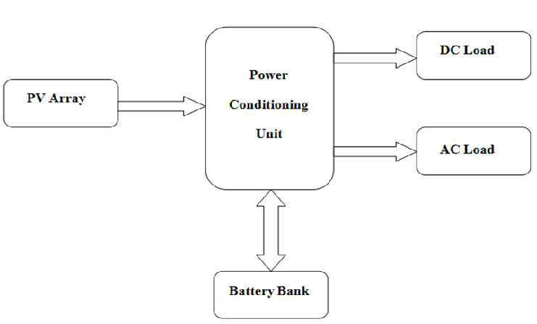

**Figure 3.1.Standalone PV-system with battery storage powering DC and AC Loads**.

**3.2 Modeling the Solar Cell**

The simplest equivalent circuit of a solar cell is a current source in parallel with a diode. The output of the current source is directly proportional to the light falling on the cell (photocurrent Iph). During darkness, the solar cell is not an active device; it works as a diode, i.e. a p-n junction. It produces neither a current nor a voltage. However, if it is connected to an external supply (large voltage) it generates a current Id,called diode (D) current or dark current. The diode determines the I-V characteristics of the cell.

Increasing sophistication, accuracy and complexity can be introduced to the model by adding in turn

* + Temperature dependence of the diode saturation current Io.
  + Temperature dependence of the photo current IL*.*
  + Series resistance Rs, which gives a more accurate shape between the maximum power point and the open circuit voltage. This represents the internal losses due to the current flow.



**Figure 3.2 Circuit diagram of the PV model**

* + Shunt resistance Rsh, in parallel with the diode, this corresponds to the leakage current to the ground and it is commonly neglected.
  + Either allowing the diode quality factor *n* to become a variable parameter (instead of being fixed at either 1 or 2) or introducing two parallel diodes with independently set saturation currents.

In an ideal cell Rs *=* Rsh *=* 0, which is a relatively common assumption. For this paper, a model of moderate complexity was used. The net current of the cell is the difference of the photocurrent, IL and the normal diode current Io.

(3.1)

The model included temperature dependence of the photocurrent ILand the saturation current of the diode Io.

IL=IL(T1)+Ko(T-T1) (3.2)

(3.3)

(3.4)

(3.5)

A series resistance *Rs* was included; which represents the resistance inside each cell in the connection between cells.

(3.7)

(3.8)

The shunt resistance Rshis neglected. A single shunt diode was used with the diode quality factor set to achieve the best curve match. This model is a simplified version of the two diode model presented by Gow and Manning. The circuit diagram for the solar cell is shown in Figure 3.2.

**3.2.1 Current-Voltage (I-V) Curve For A PV Cell**

A typical I-V characteristic of the solar cell for a certain ambient irradiation *G* and a certain fixed cell temperature (T), is shown in Figure 3.3 For a resistive load, the load characteristic is a straight line with scope I/V=1/R. It should be pointed out that the power delivered to the load depends on the value of the resistance only .A typical current-voltage I-V curve for a solar cell



**Figure 3.3 Typical I-V characteristic of the solar cell**

However, if the load Ris small, the cell operates in the region M-Nof the curve (Figure 3.3), where the cell behave as a constant current source, almost equal to the short circuit current. On the other hand, if the load Ris large, the cell operates on the regions P-Sof the curve, the cell behaves more as a constant voltage source, almost equal to the open-circuit voltage. A real solar cell can be characterized by the following fundamental parameters, which are also sketched in Figure 3.3.

* Short circuit current: Ish = Iph. It is the greatest value of the current generated by a cell. It is produce by the short circuit conditions: *V* = 0.
* Open circuit voltage correspond to the voltage drop across the diode (p-n junction), when it is transverse by the photocurrent Iph(namely IL = Iph), namely when the generated currents is I= 0. It reflects the voltage of the cell in the night and it can be mathematically expressed as:

(3.9)

Where is known as thermal voltage and Tis the absolute cell temperature.

* Maximum power point is the operating point A (Vmax, Imax)in Figure 3.3, at which the power dissipated in the resistive load is maximum: Pmax =Vmax*Imax.
* Maximum efficiency is the ratio between the maximum power and the incident light power.

(3.10)

Where ‘Ga’is the ambient irradiation and ‘A’is the cell area.

* Fill factor is the ratio of the maximum power that can be delivered to the load and he product of Isc and VOC:

(3.11)

The fill factor is a measure of the real I-Vcharacteristic. Its valued is higher than 0.7 forgood cells. The fill factor diminishes as the celltemperature is increased.

The open circuit voltage increases logarithmically with the ambient irradiation, while the short circuit current is a linear function of the ambient irradiation. The dominant effect with increasing cell’s temperature is the linear decrease of the open circuit voltage, the cell being thus less efficient. The short circuit current slightly increases with the cell temperature.

**3.2.2 Considerations In The Model About Environment Variables**

The influence of the ambient irradiation *G* and the cell temperature *T* on the cell characteristics can be obtained from the model equations. The PV cell photocurrent IL(A) is directly proportional to solar irradiance *G*(W/m2). When the solar cell is short circuited, negligible current flows in the diode. Hence the proportionally constant in (eqn. 3.3) is set to the rated short circuit current ISC at is delivered under rated irradiation. Solar intensities are commonly normalized with respect to full solar radiation at sea level with average humidity and aerosol particulate concentration (1 Sun = 1000Watt/m2). Though somewhat contrary to intuition, PV cell performance does not degrade significantly between full sun and cloudy conditions. The power output decreases nearly lineally with incident solar energy, but efficiency is nearly flat over the region of concern.

The relationship between the photo-current and temperature is linear (eqn. 3.2) and is deduced by noting the change of photo-current with the change of temperature (eqn. 3.4). When the cell is not illuminated, the relationship between the cell’s terminal voltage and current is given by the Shockley equation. When the cell is open circuited and illuminated, the photo-current flows entirely in the diode. The I-V curve is offset from the origin by the photo generated current IL (eqn. 3.1). The value of the saturation current Ioat 25°C is calculated using the open circuit voltage and short circuit current at this temperature (eqn. 3.6). An estimate must be made of the unknown “ideality factor”. Green states that it takes a value between 1 and 2, being near one at high currents, rising towards two at low currents. A value of 1.3 is suggested as typical in normal operation, and may be used initially, until a more accurate value is estimated later through curve fitting. The relationship of I0to temperature is complex, but fortunately contains no variables requiring evaluation (eqn. 3. 5) The series resistance of the panel has a large impact on the slope of the I-V curve at V = VOC. Equations 3.7 and 3.8 are found by differentiating equation 3.1, evaluating at V = VOC, and rearranging in terms of Rs.

**3.3 Mat lab Model Of The PV Module**

The BP SX150 PV module was chosen for modeling, due is well-suited to traditional applications of photovoltaic. The BPSX 150 module provides 150 watt of nominal maximum power, and has 72 series connected polycrystalline silicon cells. The key specifications are shown in Table 3.1. The model of the PV module was implemented using a MATLAB program and that will be converted in to the SIMULINK model shown in the Figure 3.4.

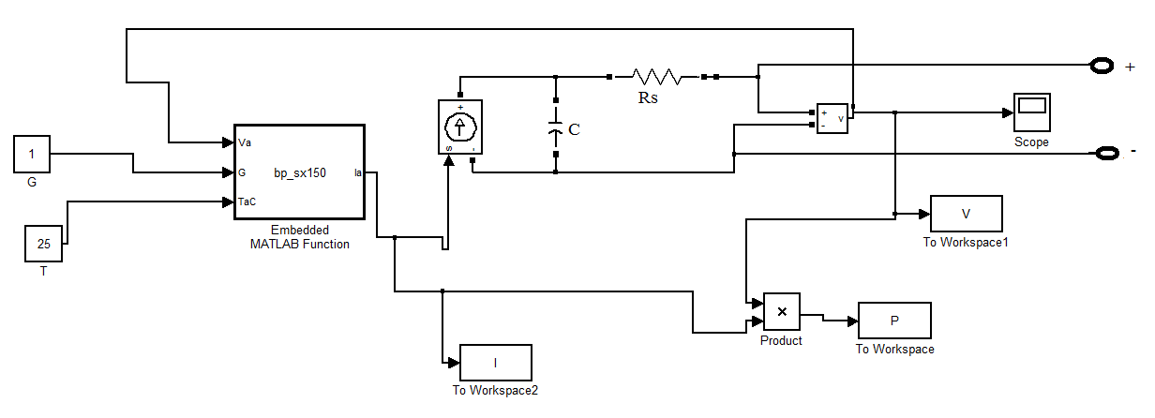

**Figure 3.4 Matlab/Simulink model of BPSX 150 solar panel**

The model parameters are evaluated during execution using the equations listed on the previous section. The program, calculate the current *I*, using typical electrical parameter of the module (ISC,VOC), and the variables Voltage, Irradiation (G), and Temperature (T).

**Table 3.1 Electrical characteristics of BPSX 150 solar cell at 250C, 1000w/m2**

|  |  |
| --- | --- |
| Maximum power (Pmax) | 150W |
| Voltage at Pmax = (Vamp) | 34.5V |
| Current at Pmax = (Imp) | 4.35A |
| unwarranted maximum Pmax | 140W |
| Short – circuit current (Isc) | 4.75A |
| Open – circuit voltage (Voc) | 43.5V |
| Temperature coefficient of Isc | (0.065±0.015)%/0C |
| Temperature coefficient of voltage | -(160±20)mV/0C |
| Temperature coefficient of power | -(0.5±0.05)%/ 0C |
| NOCT | 47±20C |
| Maximum series fuse rating | 20A (U Version)  15A (S,L Version) |
| Maximum series fuse rating | 600V (U.S.NEC rating)  1000V (TUV Rhineland rating) |

**3.4 Simulation Results**

The I-V and P-V characteristics for various irradiance at fixed temperature (T=25 *0C*), obtained from the model are shown in Figures 3.5 and 3.6, respectively.

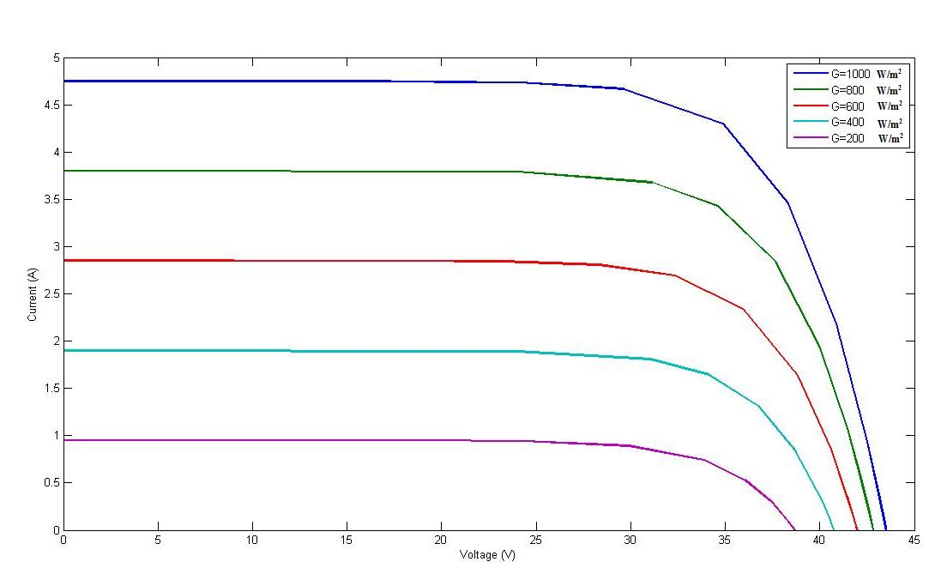 **Figure 3.5 I-V characteristic for a PV cell at a constant temperature of 25*0C***

Figures 3.6, 3.7 show the I - V characteristics for different values of temperature and fixed irradiance of 1000*W=m*2 respectively. From the figures, we can conclude that when the irradiation is 1000*W=m*2, which corresponds approximately to a cloud-free, sunny day, the upper curve shows that the open-circuit voltage of the cell is about 43.2 Volt. As the load (current) of the cell increases, the voltage decreases and at short-circuit (voltage = 0) the current is approximately 4.75 A.

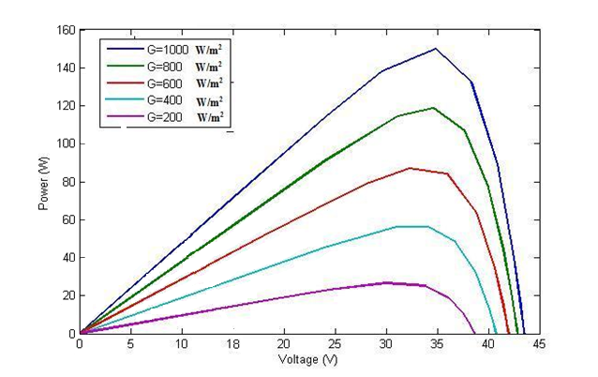

**Figure 3.6 P-V characteristic for a PV cell at a constant temperature of 250*C***

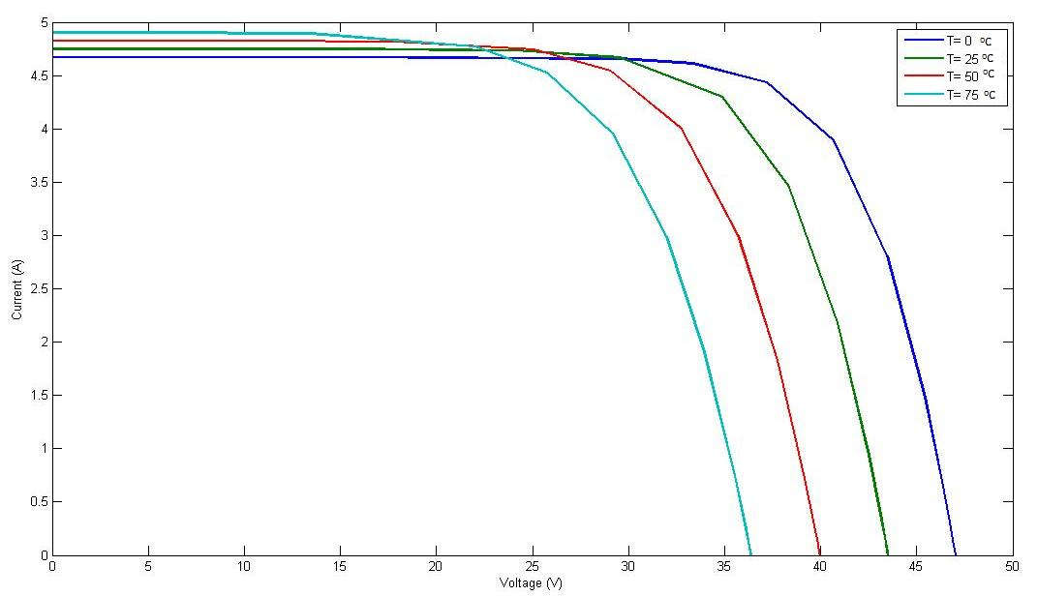

**Figure 3.7 I-V characteristic for a PV cell at constant G= 1000*W/m*2**

At open circuit and at short-circuit, no power is produced. At a point called the maximum power point (MPP), maximum power is gained from the PV-cell. To visualize this, a rectangle can be drawn from a point on the curve to the x and y-axis. For the point where this rectangle has the largest area, the maximum power is generated. At a lower irradiation, the short-circuit current decreases approximately linearly with irradiation. The open circuit voltage does not decrease as much until a very low irradiation. However, the open circuit voltage is much more affected by the temperature of the PV-cell. At a higher temperature, the open circuit voltage decreases. The phenomenon has quite a large impact and it decreases the output power by approximately 15% at a temperature increase from 25*0C* to 75*0C*.

The effect of irradiance and cell temperature on I-V characteristic curve is shown in Figures 3.5 and 3.7. Figure 3.5 shows that the maximum power output varies almost linearly with the irradiance. Figure 3.7 shows that the maximum output power from the PV decreases as the temperature increases.

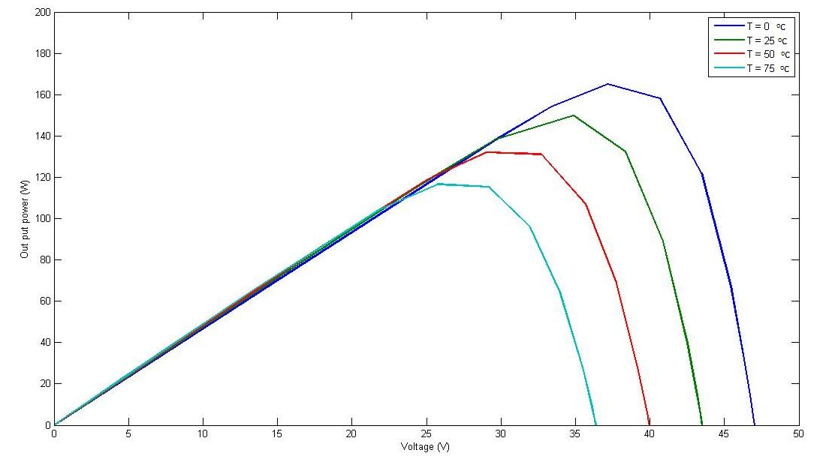

**Figure 3.8 P-V characteristic for a PV cell at constant G= 1000*W/m*2**

**4. MODELING OF POWER CONDITIONING UNIT**

**4.1 Introduction**

The power conditioning system provides regulated dc or ac power appropriate for the application. The Figure 4.1 shows the block diagram of the power conditioning system. The output of the Solar PV is an unregulated DC voltage and it needs to be conditioned in order to be of practical use. The power conditioner section converts the raw power into useable power for different applications. The power conditioning unit also controls electricity’s frequency and maintains harmonics to an acceptable level. The purpose of conditioners is to adapt the electrical current from Solar PV system to suit the electrical needs of the application.

**LOAD**

**POWER CONDITIONING UNIT**

**SOLAR PV ARRAY**

**Figure 4.1 Power conditioning system**

The general configuration of the system will be the Solar PV followed by a boost converter followed by an Grid Connected inverter. In general, the load for the boost stage is a filter and the inverter system. The boost converter will be operated in the voltage control mode. The boost converter is ideally suited for interfacing the inverter system with the Solar PV array.

Based on the load conditions, the boost stage can be commanded to draw a specific amount of current from the Solar PV with a ripple well defined by the frequency, size of the inductor, and duty ratio. Similarly, the inverter is used for the interfacing of the Solar PV system to the load to provide voltage/current with proper frequency phase and magnitude where the input for the inverter comes from the boost converter stage and the inverter (with the filter) becomes the load for the boost converter. The power conditioner is also used for the grid connection of the sources. An electrical power-generating system that uses Solar PV as the primary source of electricity generation and is intended to operate synchronously, and in parallel with the electric utility network is a grid-connected system.

**4.2 Dc-Dc Converter Control Loop**

The output voltage of Solar PV is uncontrolled dc voltage which fluctuates with change in irradiance, temperature and load variations. This raw voltage, which is unregulated and uncontrolled, is regulated to an average value with help of dc/dc converter. The controlled voltage thus obtained is fed to the dc/ac inverter after it is filtered. The power obtained from this inverter is added to the grid. This system can be used as a standalone after the dc/dc converter stage if dc power is needed or after the dc/ac stage if ac power is needed.

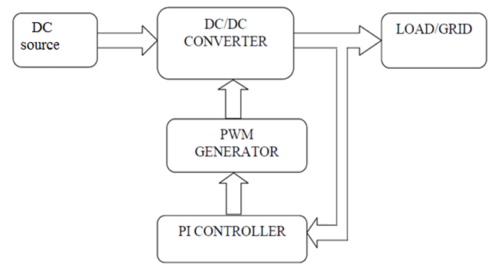

**Figure.4.2 DC-DC converter control loop**

This unregulated voltage has to be adjusted to a constant average value (regulated dc voltage) by adjusting the duty ratio to the required value. The voltage is boosted depending upon the duty ratio. The duty ratio of the boost converter is adjusted with the help of a PI controller. The duty ratio is set at a particular value for the converter to provide desired average value of voltage at the output, and any fluctuation in the solar PV in the load or in the characteristics of solar PV takes the output voltage away from the desired average value of the voltage.

The PI controller changes the duty ratio properly to get the desired average value. The duty ratio of the converter is changed by changing the pulses fed to the switch in the dc/dc converter circuit by the PWM generator.

**4.2.1 Modeling of Dc/Dc Converter**

A boost converter (step-up converter) is a power converter with an output DC voltage greater than its input DC voltage. It is a class of switching-mode power supply (SMPS) containing at least two semiconductor switches (a diode and a transistor) and at least one energy storage element. Filters made of capacitors (sometimes in combination with inductors) are normally added to the output of the converter to reduce output voltage ripple. Figure 4.3 shows the circuit diagram of the DC to DC boost converter.

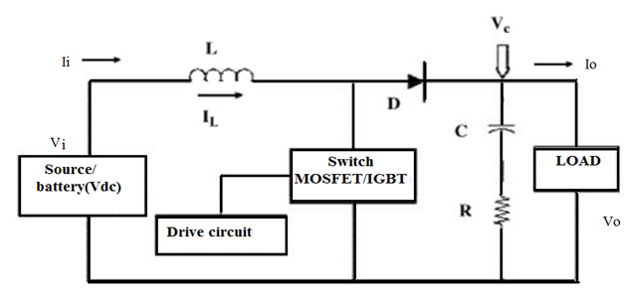

**Figure 4.3 Circuit diagram of DC/DC Converter**

Pin= Vi * Ii  (4.1)

Ii= IL  (4.2)

D=1-(Vi/Vo) (4.3)

For continuous conduction the designed values of L, C, R is

L = (D (1-D)*R))/ (2*f) (4.4)

C = (D/2*f*R) (4.5)

Where

‘D’ is the Duty Ratio

‘R’ is the load resistance

‘f’ is the switching frequency

**4.2.2 Simulation Model of Dc/Dc Converter**

The DC/DC converter boosts the low unregulated voltage to a desired regulated voltage. The for the DC/DC converter is the Solar PV voltage and output of the DC/DC converter is connected to the inverter circuit which was shown in Figure 4.4

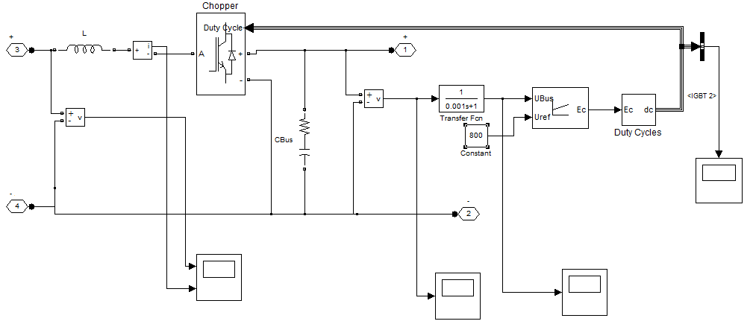

**Figure 4.4 Simulink Model of DC/DC Converter**

**4.2.2.1 Output Voltage Wave Form of Dc/Dc Converter**

The output voltage of the DC/DC converter is maintained almost constant at 800V throughout the loading conditions. This is achieved by using a PI controller along with the DC/DC converter. The function of the PI controller is to reduce the change in error obtained during the loading. This error will be minimized by choosing the appropriate KP and KI values of the PI controller. The appropriate values of the KP and KI are 0.0005 and 0.15 respectively which was shown in Figure 4.5

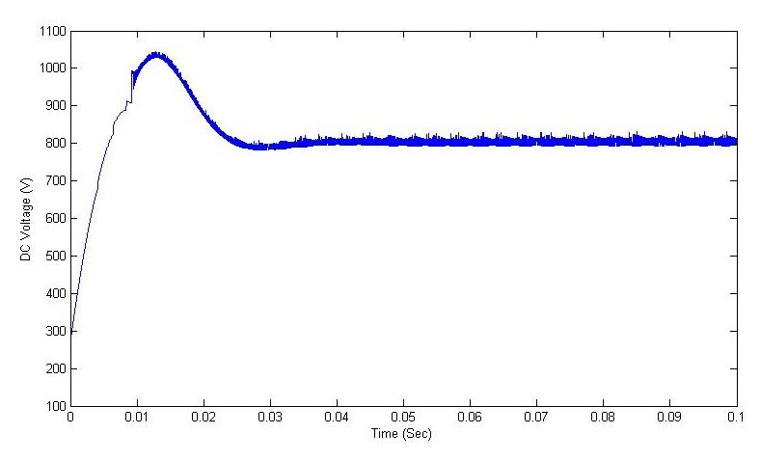

**Figure 4.5 Output Voltage Waveform Of DC/DC Converter**

**4.2.2.2 Duty Ratio Of Dc/Dc Converter**

During the loading conditions output voltage will be changed due to the change in input current. But we require a desired constant output voltage and this is possible by changing the duty ratio (DR) of the converter appropriately. According to this DR, the gate pulses will be generated and the output voltage will be controlled which was shown.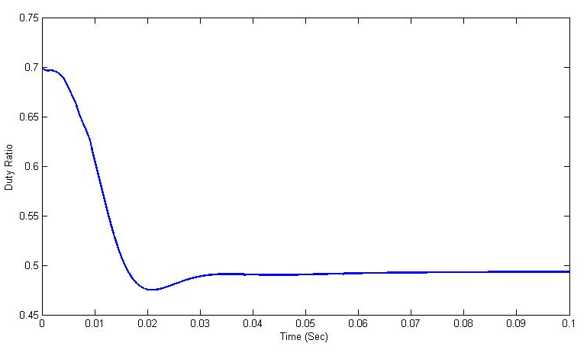

**Figure 4.6 Duty ratio of DC/DC Converter**

**4.3 Dc/Ac Grid Connected Inverter Control Loop**

Inverters are devices that change the DC electricity produced by DC sources into ac electricity. Utility – interactive inverters are used in systems connected to a utility power line. The inverters produce AC electricity in synchronization with the power line, and of a quality acceptable to the utility company once the control strategy is implemented.

The full-bridge inverter implements a Hysteresis Current Control as the control method. These control method provides robust current regulation, achieve unity power factor, low THD and optimize the PV energy extraction suitable for grid connected PV systems.

**4.3.1 Current Control**

Among multiple functions of grid connected systems, the current control plays one of the most important roles. The performance of the complete system largely depends on the quality of the applied current control strategy. It has to full fill basic requirements, such as low harmonic distortion of the output current, high dynamic response, regulation of the dc-link voltage and, in a number of cases, provide bi-directional power flow.

The desire to propose a current control strategy which combines most of these requirements has encouraged many researches in the last two decades. A large number of current controller techniques have been described for different applications, namely ac drives, active filters, uninterruptible power supplies (UPS), ac-dc converters, etc. These control strategies achieve the same basic steady-state goal of controlling the fundamental input or output current waveform; however they differ on the implementation complexity, dynamic response and output current harmonic contents.

**4.3.1.1 Current Control Techniques**

Among multiple functions of grid connected systems, the current control plays one of the most important roles. The performance of the complete system largely depends on the quality of the applied current control strategy. It has to fulﬁl basic requirements, such as low harmonic dis- torsion of the output current, high dynamic response, regulation of the dc-link voltage and, in a number of cases, provide bi-directional power- ﬂow . The desire to propose a current control strategy which combines most of these requirements has encouraged many researches in the last two decades. A large number of current controller techniques have been described for diﬀerent applications, namely ac drives, active ﬁlters, uninterruptible power supplies (UPS), ac-dc converters, etc. These control strategies achieve the same basic steady-state goal of controlling the fundamental input or output current waveform; however they diﬀer on the implementation complexity, dynamic response and output current harmonic contents. Although the existing current control techniques vary from very sim- ple hysteresis methods to complex analytical approaches, they are all based on the same basic principle. The load current is controlled by cor- rectly modulating the converter input/output voltage. This basic con- cept is better explained by analyzing the simpliﬁed scheme of a three-

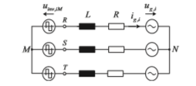

**Figure 4.7 Simpliﬁed schematic of a three-phase grid connected system.**

phase inverter connected to the grid through a ﬁrst order output ﬁlter shown in Figure 4.14. The general phase voltage equation is expressed in (4.7), where uinv,iM represents the inverter output voltage referred to the mid-point M, R and L the output ﬁlter parameters, while ug,i and ig,i symbolize the grid voltage and current quantities. The coeﬃcient i represents the three phases R,S and T.

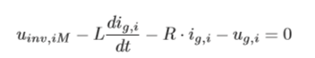(4.6)

Neglecting the ﬁlter series resistance R the equation can be rewritten as follows:

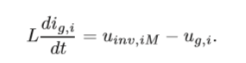 ( 4.7)

Considering the grid phase voltage ug,i constant over one switching frequency, equation (4.7) shows that the phase output current ig,i can be controlled by adjusting the inverter output phase voltage uinv,iM. This analysis is only valid if the mid-point M is physically or virtually connected to the neutral-point N such that the common mode voltage does not aﬀect the phase voltages. This topic will be covered in more detail in the next chapters. The current control concept can also be explained using phasor repre- sentation of the voltage and current fundamentals as illustrated in Figure 4.7. The inverter output current is indirectly regulated by controlling the amplitude and phase angle (ϕ) of the inverter output voltage pha- sor. In the ﬁrst case (Figure 4.8 (a)) where the inverter voltage is leading

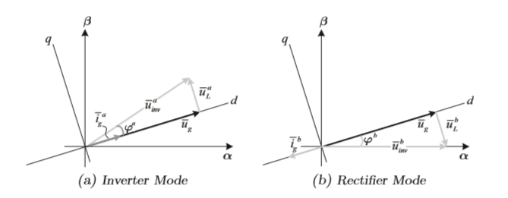

**Figure 4.8 Vector diagram for the three-phase grid connected system.**

the grid voltage with an angle ϕa, the system works as an inverter with the resulting current in phase with the grid voltage. However, if the magnitude of the inverter output voltage vector is maintained but the angle converted to negative (ϕb = −ϕa ), the resulting current would lie in the opposite direction and consequently the system would operate as a rectiﬁer(Figure 4.8 (b)). The principle of modulating the inverter output voltageis often achieved based on the comparison of the actual measured current ig,i to the de- sired reference ig,i,ref as illustrated in Figure 4.9 The error signal ∆ig,i is used by the current controller to either provide the control signals (uc,i) to the modulator or directly generating the switching states si for the converter power devices. In the last case, the current controller and modulator are assumed to be a single block.

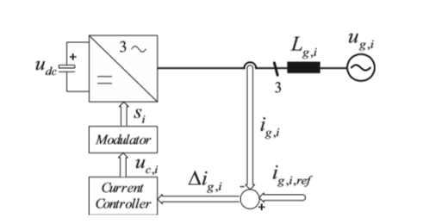

**Figure 4.9 basic current control scheme**

One of the earliest introduced current control approaches based on this comparison technique is the ramp-comparison controller . It compares the control signal generated according to the current error to a triangular carrier waveform, to generate the switching states. The main advantage of this concept is that the inverter operates at a ﬁxed switch- ing frequency deﬁned by the frequency of the triangular carrier wave- form. However, the system response is aﬀected by stability requirements of the feedback loop, which also depends to load parameters. Moreover, it performs an inherent phase and amplitude error even in steady-state operation. The dependency of load parameters is eliminated for the hysteresis control approach which uses hysteresis comparators to select the proper switching states based on the comparison of the current error with switching boundaries deﬁning a hysteresis band . Although simple and extremely robust, this control technique exhibits several un- satisfactory features such as varying modulation frequency over a fun- damental period. A good performance concerning steady-state accuracy is obtained using synchronous reference frame transformation . Using rotating dq-reference frame theory, ac values become dc quanti- ties and can be easily regulated using PI controllers. However, stability and dynamic performance are again inﬂuenced by load parameters.

A new tendency of implementing current control techniques into di- rect digital controllers using microprocessors has been of particular interest, thanks to advantages in terms of ﬂexibility, insensitivity to age eﬀects and thermal drifts. Moreover, new generations of microcon- trollers and digital signal processors (DSPs) are released with higher processing capability and with additional number of peripherics. This trend has boosted the utilization of control schemes that demand com- plex on-line processing and stored elements. The Direct Power Control (DPC) concept ﬁts into these characteristics, since it requires an instantaneous calculation of the active and reactive powers that are compared to the desired references. The error signals are used to select from a stored switching table the optimum switching state. Another approach which is increasing force with the development of faster DSP devices is the predictive control . It calculates the opti- mum inverter voltage required to drive the actual currents according to the reference values. Although it gives optimum performance in terms of both response time and accuracy, it takes more calculations and requires a good knowledge of the load parameters.

Each of the existing current control techniques has its own characteristics’ and strengths, which makes it suitable for speciﬁc applications. Furthermore, properties associated to switching frequency, load current distortion and dynamic behavior usually contradict each other. There- fore, the choice of the most appropriate current control method means searching for the best compromise between these characteristics and the nature of the application.

**4.3.1.2.Ramp-Comparison Control**

The ramp-comparison current controller uses proportional-integral (PI) error compensators and a ﬁxed frequency triangular carrier to generate the gate signals of the converter power switches . Based on the phase current error (∆ig,i) the PI controller derives the modulating signals (uc,i) to be compared to the pulse width modulator (triangular carrier) as shown in Figure 4.10.

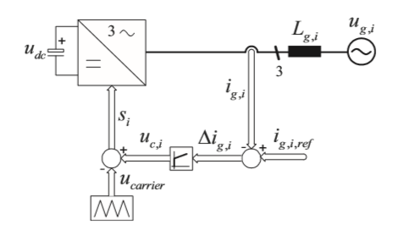

**Figure 4.10 Ramp-comparison current control schemes**

Some constraints are imposed on the controller design to guarantee the proper operation of the system. Even though the PI controller gain shall be selected high in order to reduce the tracking error, it must remain low enough to avoid the amplitude of the control signal (uc,i) to exceed the carrier signal. Furthermore, the gain is also limited to ensure that the slope of the control signal is always less than the slope of the triangular carrier signal, thus avoiding multiple crossing which would result in increased switching frequency and\or switching losses. Figure 4.11 illustrates the inverter output voltage resulting for the comparison between the control signal uc,i and the triangular carrier

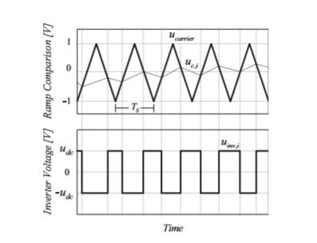

**Figure 4.11 Inverter output voltage achieved with the comparison between the control signal uc,i and the triangular carrier ucarrier**.

ucarrier. If the control signal is higher than the triangular waveform, the switches are activated to apply udc to the output. On the other hand, if the control signal is lower than the triangular carrier, an output voltage equal to −udc is produced. Additionally, the points of intersection deﬁne the switching instants of the power switches. This maintains the switching frequency constant, since the triangular carrier is operated with a ﬁxed frequency. However, despite this main advantage, the control concept has an inherent am- plitude and phase tracking error, as the PI controller has to process AC signals. Furthermore, it can be aﬀected by stability requirement of the current feedback loop which is highly dependent to load parameters.

**4.4. Hysteresis Control**

The basic concept of the hysteresis current control is to switch the out- put voltage level (+udc to −udc for a two-level system) appropriately whenever the measured current goes above or below a given tolerance boundary . The current errors resulting from the comparison between measured currents and respective phase current references are controlled using three independent hysteresis comparators as illustrated in Figure 4.12 by the simpliﬁed diagram of a typical three-phase hystere- sis current controller. Since the switching signals si (i = R,S,T) are produced directly

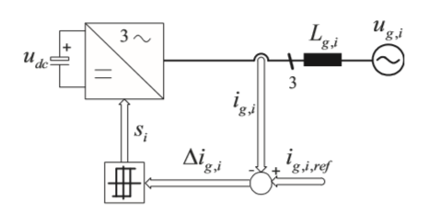

**Figure 4.12 Hysteresis current control scheme**.

based on the hysteresis comparison of the three phase current errors, the hysteresis current control approach provides excellent dynamic per- formance, limited only by the switching speed and load time constant. Additionally, independence of load parameters concerning stability, ro- bustness and very simple implementation make the hysteresis approach the current control method of choice for diverse types of applications. However, the classical hysteresis current controller with ﬁxed hystere- sis band has the disadvantage that the modulation frequency varies over a fundamental inverter period . That is mainly caused because the switching frequency is not only dependent on constant parameters such as the output ﬁlter inductance, dc-link voltage, desired current ripple (width of band), but is also inﬂuenced by the periodic variation of the ac grid voltage as shown by the equation .

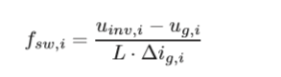 (4.8)

This variable switching frequency results in an undesirable spread of the ripple current harmonics, which complicate the design of the output ﬁlter and may generate unwanted resonances on the utility grid. Another important factor which inﬂuences the switching frequency is the interference between the commutations of the three phases, inherent to three-phase system without a neutral connection . In this case, each phase current not only depends on the corresponding phase voltage but it is also aﬀected by the voltage of the other two phases. Furthermore, due to this interaction between the phases the instant neous current error is not limited within the tolerance

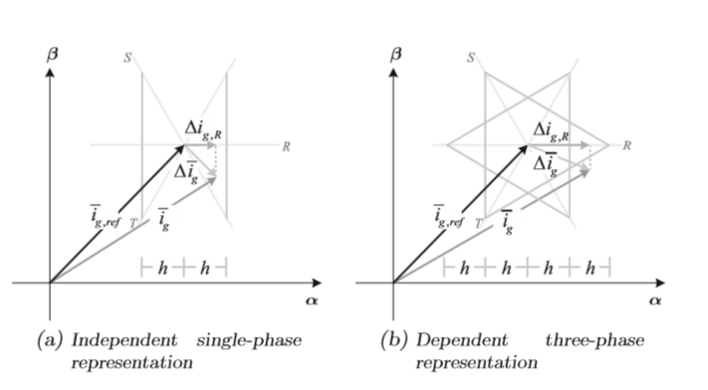

**Figure 4.13 Vector representation of hysteresis control for (a) a set of in- dependent three-phase controllers and (b) with the interaction between phases**.

reach double of this value. If the output voltage of one phase should be reversed in order to maintain the current error within the given toler- ance band, this transition can be made impossible by the switching state of the other two phase controllers. Therefore, the current error contin- ues to increase until it reaches twice the band width where a switching action is enforced in another phase according to iR + iS + iT = 0. A vector diagram can be used to better explain such characteristic. Figure 4.13 (a) illustrates the vector representation of the current ref- erence, actual measured current and the resulting current error along with R, S and T axes of a three-phase set of coordinates. The phase cur- rent error ∆ig,R is obtained through the projection of the current error vector ∆¯ ig on the corresponding R axis. Assuming three independent phases, the hysteresis controller of phase R switches appropriately the inverter leg R when ∆ig,R exceeds the hysteresis band h. The tolerance band is represented in Figure 4.13 (a) by two lines perpendicular to the R axis. This representation is extended to the other two phases in the Figure 4.13 (b), considering now a three-phase system with insulated neutral. In the moment the projected current error ∆ig,R crosses the ﬁrst toler- ance band h, the converter automatically generates an output voltage R to keep the current within the desired band. However, due to the interaction between phases the correct action is completed only when the current error reaches another phase switching boundary, resulting in the worst case in a current control error of twice the hysteresis band. Several authors have tried to reduce this interaction between phases in order to achieve a constant switching frequency by modu- lating the hysteresis band over one fundamental cycle according to the ac-voltage . However, although the inclusion of new concepts into the classical hysteresis control increases the level of complexity, they do not aﬀect dynamic response and stability issues. Therefore, constant switching frequency hysteresis control emerges as a well suited approach for high performance high-speed applications.

**4.4.1.Voltage-Oriented Control**

Voltage-Oriented Control (VOC) scheme uses the rotating dq frame the- ory to ensure a zero steady-state output current error. By transforming ac phase quantities to dc components, the inﬁnite dc gain of the PI con- trollers are able to lead actual dq currents to the desired values without introducing static errors . In the particular case of the VOC scheme the synchronous transfor- mation is oriented such that the d-axis is aligned to the grid voltage vector as shown in Figure 4.14 The load current vector ¯ ig, is divided into rectangular components, where the component ig,d determines the active power whereas ig,q controls the reactive power ﬂow.

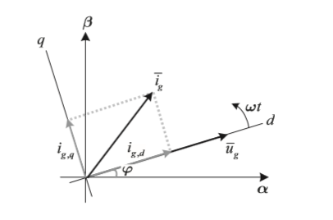

**Figure 4.14 Synchronous dq transformation oriented on the grid voltage vector**

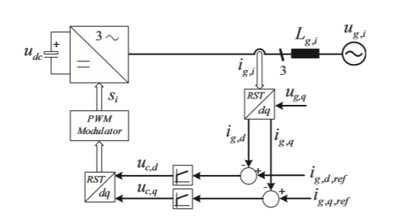

**Figure 4.15 illustrates the VOC principle involving the use of rotating synchronous rectangular coordinates**.

The three measured output phase currents are converted to dq components using synchronous reference frame transformation and compared to the respective reference values (ig,dq,ref). Two PI regulators compensate any existing error by gener- ating appropriate control voltages uc,d and uc,q, which are transformed back to phase quantities and used as inputs by the pulse-width mod- ulation (PWM) block to generate the command signals to the power devices.

Although, the described approach allows eﬃcient regulation of active and reactive power ﬂow using two distinct loops (ig,d and ig,q), the control of these variables are not performed completely independent. Equation shows how in the dq-frame the dq voltage equations of the three-phase grid connected VSI (Figure 4.1) are dependent due to the cross-coupling terms ωL·iq and ωL·iq.

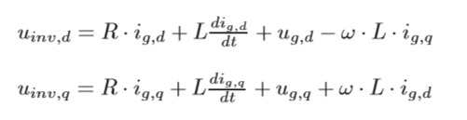 (4.9)

In order to apply independent controllers for the two coordinates the inﬂuence of the q-axis on the d-axis component and vice-versa has to be removed. This is performed by creating a decoupling network using the block containing ωL information, as shown in Figure 4.23 Furthermore, the feed-forward grid voltage (ug,d and ug,q) compen- sation can eﬀectively reduce any grid harmonic disturbance.

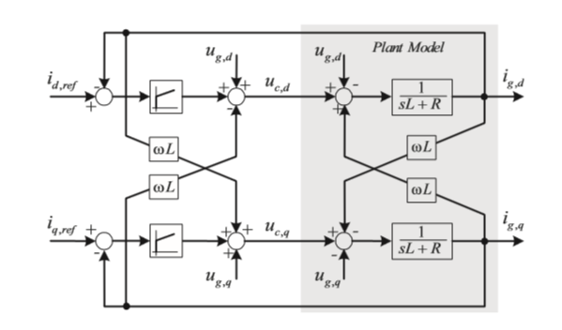

**Figure 4.16 Rotating frame VOC employing a dq decoupling network**

By including the decoupling and feed-forward control loops to the existing approach, the linear transfer function of ig to uc is given by:

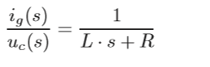 (4.10)

Therefore, the parameters of the two PI regulators can be easily calcu- lated based on classical design methods. Poles and zeros of the compen- sator should be located with the intention to achieve good static and dynamic performance of the system, and at the same time providing suﬃcient stability margins. Although giving very good performance concerning steady-state ac- curacy, the voltage oriented control approach is still sensitive to load parameters, which may inﬂuence the dynamic response and the system stability. However, it has the particular advantage of independent control of the active and reactive current components, which translates directly into active and reactive powers ﬂow control. This might be advantageous for grid connected applications.

**4.4.1.2 Direct Power Control**

The Direct Power Control (DPC) concept proposed by Noguchi slightly diﬀers from the other current control techniques which use

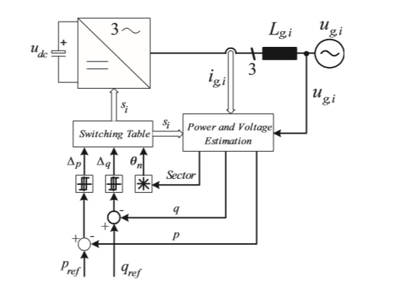

**Figure 4.17 Direct Power Control scheme**.

inner current control loops to directly regulate the load currents. Instead of that, DPC (Figure 4.17) regulates instantaneous phase currents in terms of active and reactive powers. It is based on the industry standard practice for ac machines known as Direct Torque Control (DTC). For the DPC approach active and reactive power variables are directly controlled in a manner analogous to torque and ﬂux control in motor drives applications. The three-phase currents and grid voltages are used to estimate the instantaneous active and reactive powers that are compared to respec- tive references. Usually, the active power reference pref is set by the dc-link voltage controller and the reactive power reference qref is ad- justed to zero to ensure unit power factor. Two hysteresis controllers based on p and q error quantities and a grid voltage position detector supply the inputs to the switching table which is in charge to select the optimum voltage space vector of the converter. The inﬂuence of each vector on the instantaneous real and imaginary powers is diverse and results in diﬀerent control dynamics. The impact of each vector is analyzed oﬀ-line and properly stored in a switching table according to the operating condition. One of the most important aspects on DPC apart from the switching table is the correct estimation of the active and reactive powers. It can be performed either based on three-phase quantities,

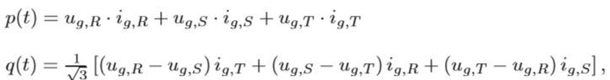 (4.11)

or using stationary αβ coordinates:

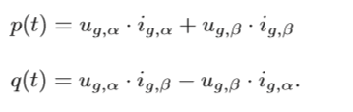 (4.12) Therefore, it excludes the necessity of synchronous reference frame transformation, which demands higher computational eﬀort. Besides that, a very simple implementation and extremely fast dynamic response are often cited as the biggest advantages of DPC. On the other hand, the variable switching frequency and fast sampling required for a digital implementation of the hysteresis controllers are disadvantageous. These drawbacks can be eliminated by replacing the hysteresis com- parators and the switching table by PI controllers and space vector

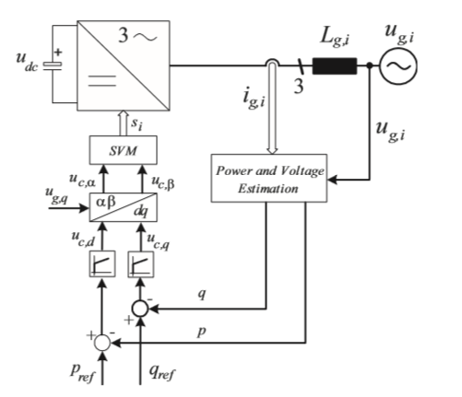

**Figure 4.18 Space Vector Modulation Direct Power Control scheme**.

modulation approach, as proposed and shown in Figure 4.18 The SVM-DPC with constant switching frequency is performed by em- ploying PI controllers to generate the control signals used by the space vector modulator to generate the switching commands. However, a syn- chronous reference frame transformation is required to convert the PI output signals into stationary αβ coordinates to used as input of the space vector modulation block.

**4.4.1.5 Predictive Current Control**

Due to the availability and continuous development of powerful and fast microprocessors, the interest in current control techniques which demand high computational eﬀort is increasing. The performance of this type of controllers is rising proportionally to the speed and calculation power of new families of microprocessors. The basic idea of the predictive current controller is to perform a fast and accurate control loop that selects the optimum control action among all possibilities, to fulﬁl a certain predeﬁned criteria . This decision is based on the knowledge of actual variable measurements and load parameters. The typical structure of a predictive current controller is shown in Figure 4.19 The "Load Model" block provides the actual load states to the "Prediction and Decision", which is considered the heart of a predictive control system. Based on the comparison of actual states and references, the optimum switching state is selected according to the de- cided criteria, which can be for example minimum switching frequency, minimum response time or minimum current distortion.

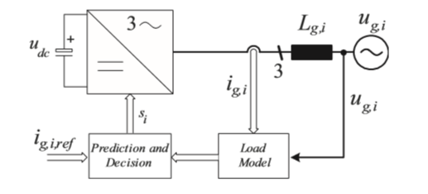

**Figure 4.19 Basic structure of the Predictive current control approach**.

Although the basic concept employed is the same, a wide variety of diﬀerent predictive control techniques has been presented. One of the ﬁrst introduced predictive control approaches was proposed by Holtz and Stadtfeld in 1983 . The method controls the current vector tra- jectory in the complex plane such that a minimum spatial error with respect to the reference vector is maintained. Due to this limited spa- tial error this approach is commonly called "Hysteresis based Predictive Control". The location of the current error tolerance area is determined by the current reference vector¯ ig,ref, as illustrated in Figure 4.20 (a). When the current vector ¯ ig intersects the boundary line, the spatial error limit is exceeded. Therefore, at this point a new switching state has to be selected in order keep the error within the desired level. The trajectory of the current vector for each possible switching state is computed and predictions are made in order to select the switching state which keeps the current within the boundary area and at the same time ensures, that the next error boundary is reached only after a maximum on- time. Therefore, it respects the second selected criteria of minimizing the switching frequency. A time representation of the error function related to the trajectory behavior of each possible candidate (Figure 4.20 (b)) gives a clear idea of the selection process. According to Figure 4.20 (b) the switching states k = 5 and k = 6 would not respect the ﬁrst constraint since the current error would continue to increase. The switching state k = 3, apparently would give the best performance concerning error and on-time, however the required number of commutations in the three phases may increase the average switching frequency. This would force the optimization con- trol loop to choose the switching state k = 2. Another slightly diﬀerent predictive current control approach, known as "Model Predictive Control", predicts the load current at the begin- ning of each sampling period and based on that, selects the voltage vector that minimizes a quality function . Typically, this qual- ity function measures the error of the load current at the next sampling instant (k + 1).

 (3.13)

There, the real iα,ref and imaginary iβ,ref components of the future reference current are determined via a second order extrapolation of the

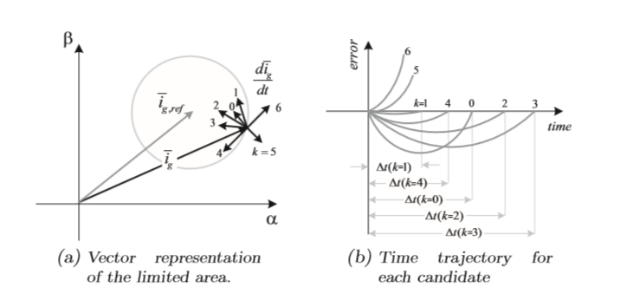

**Figure 4.20 Hysteresis based predictive control - (a) current vector and predicted trajectories and (b) predicted time behavior of each error function.**

reference current.

 (3.14)

A discrete representation of the voltage loop equation (3.1) for a given sample time Ts, can be used to predict the future value of the load current i(k + 1). The calculation is based on the measured voltage and current at the kth sample time and the ﬁlter parameters (L and R). Then inverter voltage ¯ uinv and grid voltage ¯ ug are assumed to be constant over the sample period Ts.

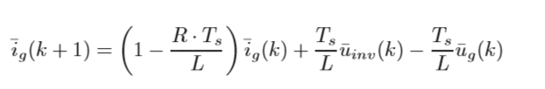 (3.15)

The controller calculates the future load current and consequently the future quality function for each possible voltage vector and selects the one which results in the minimum quality function g. This voltage vector is then applied during the next sample period. Note that, since the optimization is performed at a ﬁxed sample pe- riod Ts, the resulting switching frequency remains constant 1 Ts , unlike the previous method where the switching frequency is minimized but not constant. Besides these two predictive methods, some other concepts have been proposed in order to combine the fast dynamic response of the classical hysteresis control with the prediction characteristic of the predictive control. Digital calculations based on load parameters are performed to predict the proper hysteresis band to obtain a constant switching frequency. Similar to the voltage-oriented control strategy, the predictive current control performance is highly dependent to load parameters estimation. The presence of parameter variations or model mismatches can cause stability problems to the control loop.

**4.4.1.7 Comparison of the Control Techniques**

As described above, there is no control technique which is able to fulﬁll all requirements in terms of stability, harmonic content, dynamic re- sponse and simplicity. These speciﬁcations usually contradict each other (Table 4.1), demanding a careful analysis of the compromise between these characteristics and the nature of the application. Besides the characteristics listed in Table 4.1, there exist some addi- tional attributes that must be take into account for the selection of the control technique. The ramp-comparison for example, has an inherent amplitude and phase tracking error which limits its applications in the majority of the cases. For grid connected systems, the direct power con- trol is a practical alternative, since it provides a direct control of the active and reactive powers without any current control loop. Moreover, it turns to be robust to possible variations of the grid impedance.

**4.5.2 HYSTRESIS CONTROL**

The basic concept of the hysteresis current control is to switch the output voltage level (+Vdc to −Vdc for a two-level system) appropriately whenever the measured current goes above or below a given tolerance boundary. The current errors resulting from the comparison between measured currents and respective phase current references are controlled using three independent hysteresis comparators as illustrated in fig 4.21 by the simplified diagram of a typical three-phase hysteresis current controller.



**Figure 4.21 Duty ratio of DC/DC Converter**



**Figure 4.22 Hysteresis Current Control**

Since the switching signals Si (i = R, S, T ) are produced directly based on the hysteresis comparison of the three phase current errors, the hysteresis current control approach provides excellent dynamic performance, limited only by the switching speed and load time constant.

Additionally, independence of load parameters concerning stability, robustness and very simple implementation make the hysteresis approach the current control method of choice for diverse types of applications.

This variable switching frequency results in an undesirable spread of the ripple current harmonics, which complicate the design of the output filter and may generate unwanted resonances on the utility grid. Another important factor which influences the switching frequency is the interference between the commutations of the three phases, inherent to three-phase system without a neutral connection. In this case, each phase current not only depends on the corresponding phase voltage but it is also affected by the voltage of the other two phases.

However, although the inclusion of new concepts into the classical hysteresis control increases the level of complexity, they do not affect dynamic response and stability issues. Therefore, constant switching frequency hysteresis control emerges as a well suited approach for high performance high-speed applications.

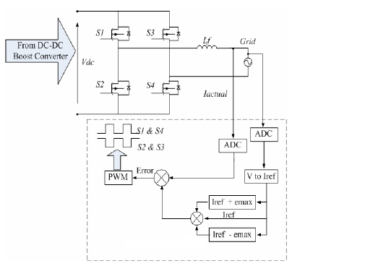

**Figure 4.23 DC/AC converter control loop**

**4.5.3 Simulation Model Of Hysteresis Current Control Grid Connected Inverter**

In this project we did the inverter output current (i.e. load current) will be compared every time with the reference current. The current error is then compared directly against a predefined band called hysteresis band to produce switching pulses for the voltage source inverter. This method controls the switches in an inverter asynchronously to ramp the current through an inductor up and down so that it tracks a reference current signal and the output of the Hysteresis controller generates 6 pulses.

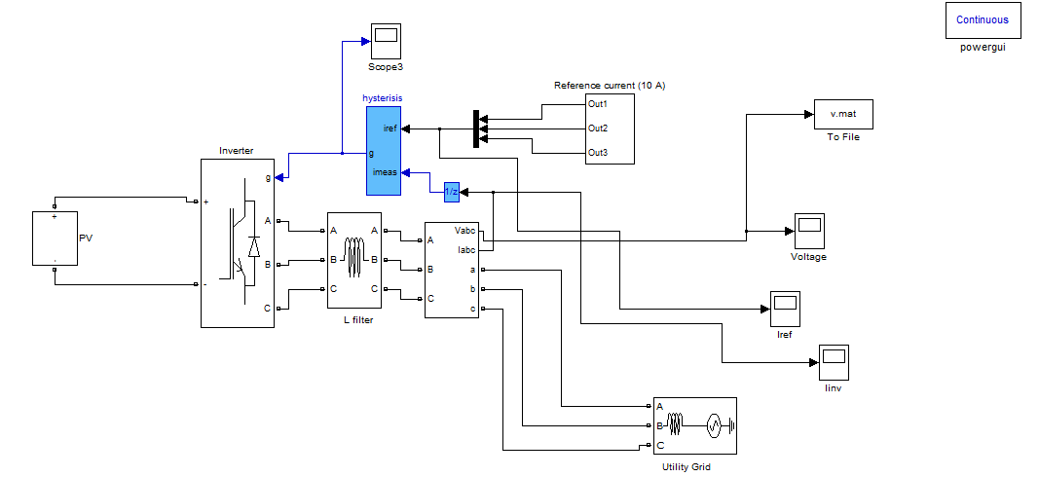

**Fig 4.24 Simulink model of Grid Connected inverter**

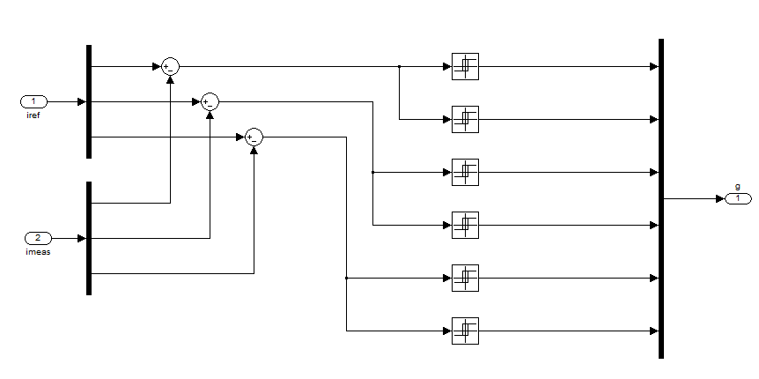

**fig 4.25 Simulink model of Hysteresis 6 pulse generator**

**4.5.4 Simulation Results**

The output voltage wave form of a grid connected inverter having the phase to phase voltage of 440V

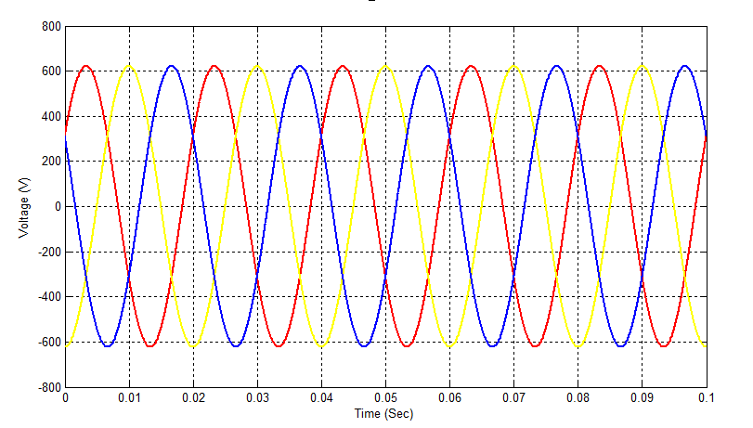

**Figure 4.26 Output Voltage of Grid-Connected Inverter**

In the figure 4.26 and 4.27 shows the reference current of 10A and the Hysteresis current control inverter tracks the 10 A current form the source i.e. Solar PV system and achieve unity power factor, low Total Harmonic Distortion (THD) and it optimizes the PV energy Extraction suitable for grid connected PV systems.

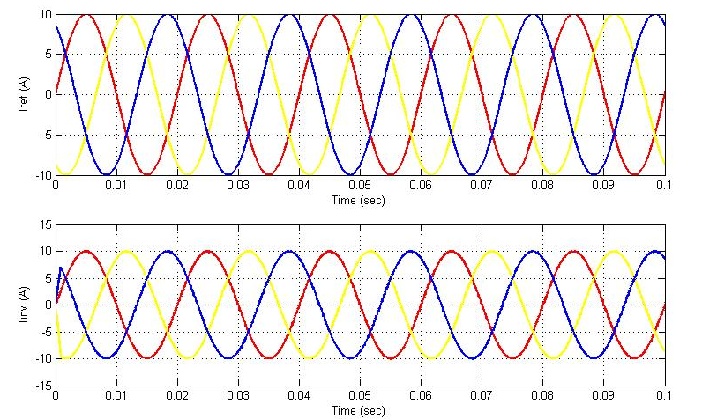

**Figure 4.27 Current Response of Grid-Connected Inverter**

In the Figure 4.28 shows that the percentage of Total Harmonic Distortion (THD) for 2 cycles is 0.21% it shows that the Hysteresis Current Control inverter provides the good power quality output.

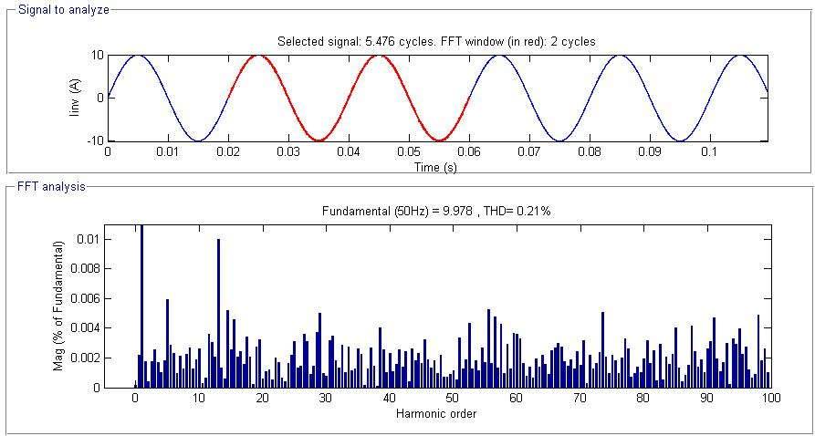

**Figure 4.28 % Of Total Harmonic Distortion (THD)**

**5. CONCLUSION**

In this final chapter, the importance, aims and outcomes of this research are highlighted and summarized. The research is discussed in terms of what it aims for and how it could contribute to the power industry’s needs. It also explores how the research could be extended and improved and how this might be done. This includes what can be done in the future to understand Grid Connected Solar PV system behavior.

It is hoped that by making optimal use of the small and varied energy sources which comprise Solar PV may be able to make a significant contribution to the distributed power generation. For instance, if the sun is out, the PV array may not provide power. The inclusion of batteries in a Solar PV system allows excess power produced to be stored, or alternatively, the excess power could be put into the main grid. In this way it is expected that Solar PV could reduce pollution and deliver reliable energy in a variety of situations as discussed in Chapter 1.

This project presents the characteristics of Solar PV cell for BPSX150 model and the modeling of DC-DC boost converter and Hysteresis Current Control Grid Connected Solar PV system behavior have been developed. The results of the solar PV system provide the current and the inverter tracks the reference current from the solar PV and supplies to the utility grid.

**REFERENCES**

1. T.E Hoff, H.J Wenger, and B.K. Farmer. Distributed generation: An alternative to electric utility investments in system capacity. Energy Policy, 24(2):137 – 147, 1996.
2. S. Blazwicz and D. Kleinschmidt. Distributed generation: System interface. [Online]. available:

<http://www.encorp.com/dwnld/pdf/whitepaper/wp_ADL_2.pdf>, May 1999.

1. T. Ackermann and V. Knyazkin. Interaction between distributed generation and the distribution network: operation aspects. In Transmission and Distribution Conference and Exhibition 002: Asia Pacific. IEEE/PES, volume 2, pages 1357–1362, Oct 2002.
2. B. Lindgren. A Power Converter for Photovoltaic Applications. PhD thesis, Department of Electric Power Engineering, Chalmers University of Technology, Göteborg, Sweden, 2000.
3. G. Walker, "Evaluating MPPT converter topologies using a MATLAB PV model," Journal of Electrical & Electronics Engineering, Australia, IEAust, vol.21, No. 1, 2001, pp.49-56.
4. J. A. Gow, C. D. Manning “Development of a photovoltaic array model for use in power electronics simulation studies,” IEE Proceedings on Electric Power Applications, vol. 146, no. 2, pp. 193- 200, March 1999.
5. A. Hansen, P. Lars, H. Hansen and H. Bindner. “Models for a Stand- Alone PV System”. Riso National Laboratory, Roskilde, December 2000, ISBN 87-550-2776-8. [Online]. Available: <http://www.risoe.dk/rispubl/VEA/ris-r-1219.htm>
6. Z. Ye, R. Walling, L. Garces, R. Zhou, L. Li, and T. Wang, “Study and Development of Anti-Islanding Control for Grid-Connected Inverters” General Electric Global Research Center Niskayuna, New York
7. M. C. Chandorkar, M. D. Divan, and R. Adapa, “Control of Parallel Connected Inverters in Standalone AC Supply Systems,” IEEE Trans. Industry Applications, vol. 29, Issue 1, pp. 136-143, January 1993.